|  |  |
| --- | --- |
| **Volume 3; Number 41 November 24th 2017** | Carlow & Kilkenny Children & Young People’s Services Committees |



[November 2017 Newsletter](http://mailchi.mp/2b11c2c6408e/kilkenny-library-news-november-2017?e=0163c6a9a6)

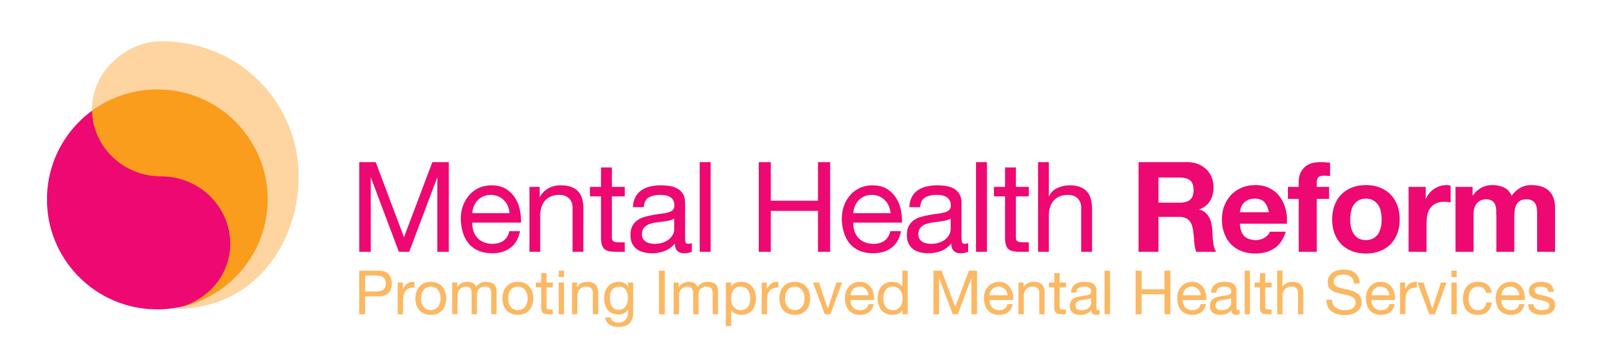

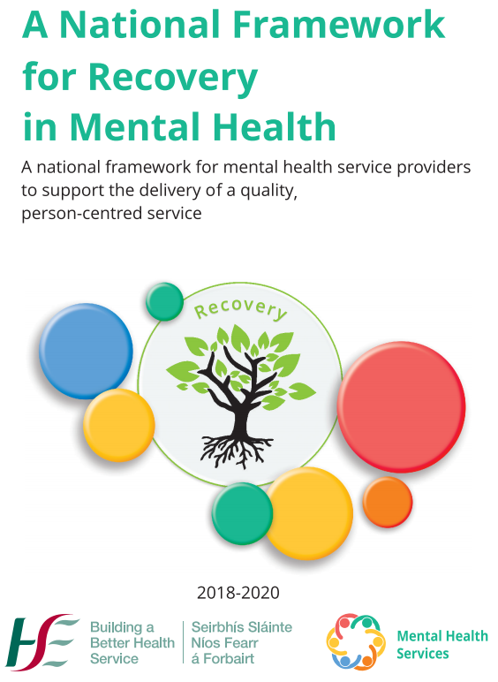

[**Download the Full Framework**](http://hse.ie/eng/services/list/4/Mental_Health_Services/advancingrecoveryireland/national-framework-for-recovery-in-mental-health/recovery-framework.pdf)

[**Download the Plain English Version**](http://hse.ie/eng/services/list/4/Mental_Health_Services/advancingrecoveryireland/national-framework-for-recovery-in-mental-health/National-Framework-Plain-English.pdf)

***Special Interest Articles:***

• Add a highlight or your point of interest here.

• Add a highlight or your point of interest here.

• Add a highlight or your point of interest here.

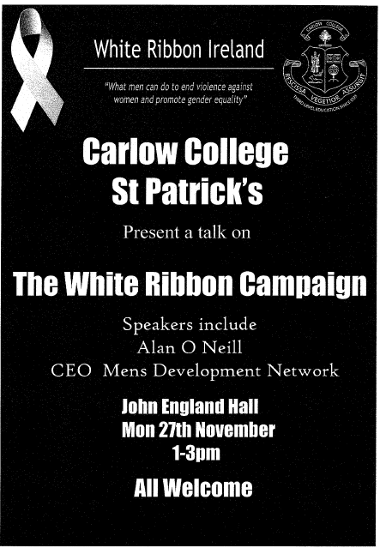

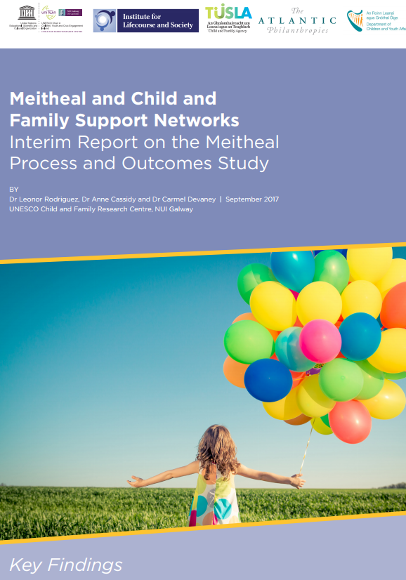

* [Key Findings](http://www.childandfamilyresearch.ie/media/unescochildandfamilyresearchcentre/dmpfilesmaster/Key-Findings-of-the-Interim-Meitheal-Report_Final.pdf)



* [Interim Report on the Meitheal Process and Outcomes Study](http://www.childandfamilyresearch.ie/media/unescochildandfamilyresearchcentre/dmpfilesmaster/Interim-Report-on-the-Meitheal-Process-and-Outcomes-Study_-NUI-Galway-2017.pdf)





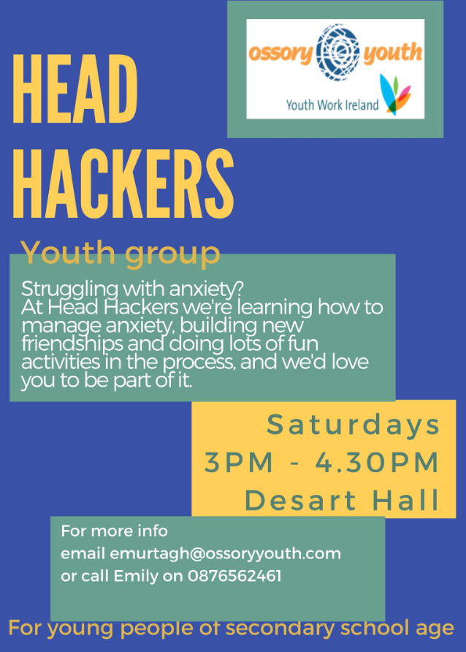



<https://www.dcya.gov.ie/documents/publications/20171106SoHowWasSchoolTodayReport.pdf>

**Giving Our Children**

**the Best Start in Life**

***Listening to the Views of Parents and Carers of Young Children***

A Survey by the Katharine Howard Foundation



The Katharine Howard Foundation is conducting a survey to coincide with [Universal Children’s Day](https://www.childrensday.ie/) which takes place on 20 November 2017

**The aim is to get parents views on what helps parents most during pregnancy and the first three years of their child’s life - and what else would help.**

**The Survey is open from 8th to 30th November and is available to access** [here](https://www.surveymonkey.com/r/BMFKS97) **or via KHF** [website](http://www.khf.ie/)**,** [Facebook](https://www.facebook.com/khfie/) **and** [Twitter](https://twitter.com/KHFdn)**.**

The findings from this consultation will be analysed and written up in report which will be made available on the website and social media avenues.

Relevant agencies will be advised of the findings which relate to their services.

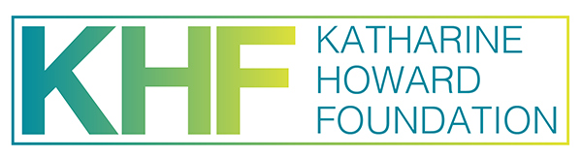

 **Sunday 3rd December 2017**

**starting at the Barrow Track @ 11:30**

Accurately measured 5km route it is also chipped race. A specially commissioned festive Jingle Bell Jog Medal for everyone registered and who completes the course. All funds raised will be spent in Carlow and will go towards providing youth work supports and activities for young people  
**Registration online or on the day from 9:30am at Carlow Rowing Club**  
Post-race refreshments served in Carlow Rowing Club  
  
Prizes for the fastest Sr Man, Sr Woman, Jr Man and Jr Woman  
  
Spot prizes for the best dressed festive outfit!  
**Further information please contact CRYS at (059) 9130476**[**https://www.popupraces.ie/events/crys-jingle-bells-jog-2/**](https://l.facebook.com/l.php?u=https%3A%2F%2Fwww.popupraces.ie%2Fevents%2Fcrys-jingle-bells-jog-2%2F&h=ATNyT7SWONg7z4cE3RT78gKzDS0EIlH7iyPbx7i7UaSwj_fnpdz0q6Ng94z3CGk_Qt5BH3Lzizi3yqnZuFXqYYL6BL4-OvHGoWZimtGzR5QQcDe7HkErXBrY0MTUE-179dFE6sYxIpfIaVISUTSelOZmRXlnq66Mkl70nJF9W_Fssij2)

**The Jingle Bells Jog is for the whole family. Walkers , jogger, runners, all welcome. Even babies in buggies. It is a great morning for the whole family**

**😀https://www.facebook.com/images/emoji.php/v9/fce/1/16/1f600.png😀https://www.facebook.com/images/emoji.php/v9/fce/1/16/1f600.png😀https://www.facebook.com/images/emoji.php/v9/fce/1/16/1f600.png😀https://www.facebook.com/images/emoji.php/v9/fce/1/16/1f600.png😀**

**Narratives of hope in mental illness** <https://www.irishtimes.com/life-and-style/health-family/narratives-of-hope-in-mental-illness-1.3275055>

**Child homelessness no longer shocks, says Fr Peter McVerry** <https://www.irishtimes.com/news/social-affairs/child-homelessness-no-longer-shocks-says-fr-peter-mcverry-1.3280980>

**Parent guide: how to find your child’s school inspection report** <https://www.irishtimes.com/news/education/parent-guide-how-to-find-your-child-s-school-inspection-report-1.3280519>

**Homelessness cost 'could be halved with less use of emergency accommodation'** <https://www.independent.ie/breaking-news/irish-news/homelessness-cost-could-be-halved-with-less-use-of-emergency-accommodation-36292580.html>

**Teenagers stressed out by exam-focused system** <https://www.independent.ie/irish-news/education/teenagers-stressed-out-by-examfocused-system-36292717.html>

**Teachers warned on students' exam stress** <https://www.independent.ie/irish-news/education/teachers-warned-on-students-exam-stress-36296561.html>

**How to save your baby or child in a choking incident - in five simple steps** <https://www.independent.ie/life/family/parenting/how-to-save-your-baby-or-child-in-a-choking-incident-in-five-simple-steps-36287556.html>

**Children choose screen time as top play activity** <http://www.irishexaminer.com/breakingnews/world/children-choose-screen-time-as-top-play-activity-812855.html>

**Testing the limits: Teaching our kids to be tenacious** <http://www.irishexaminer.com/lifestyle/healthandlife/parenting/testing-the-limits-teaching-our-kids-to-be-tenacious-462090.html>

**BRITAIN**

**Northern Ireland schools given funding for Arabic studies** <https://www.belfasttelegraph.co.uk/news/education/northern-ireland-schools-given-funding-for-arabic-studies-36285348.html>

**Emotional intelligence: why it matters and how to teach it** <https://www.theguardian.com/teacher-network/2017/nov/03/emotional-intelligence-why-it-matters-and-how-to-teach-it>

**Northern Ireland report on female genital mutilation** <https://www.belfasttelegraph.co.uk/news/northern-ireland/northern-ireland-report-on-female-genital-mutilation-36295229.html>

**We all know how important it is to spend time with our kids, but how do we make it happen?** <https://www.belfasttelegraph.co.uk/life/we-all-know-how-important-it-is-to-spend-time-with-our-kids-but-how-do-we-make-it-happen-36296039.html>

**Only 6% of care leavers go to university. They deserve better chances** <https://www.theguardian.com/teacher-network/2017/nov/07/6-per-cent-care-leavers-university-deserve-better-chances>

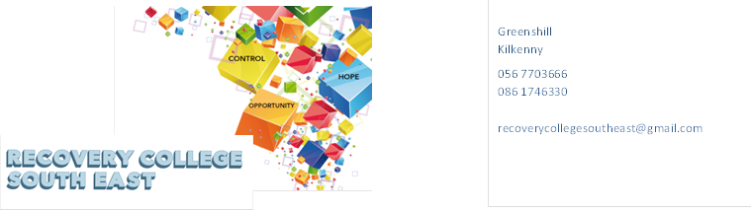

|  |  |  |  |
| --- | --- | --- | --- |
| **October 2017** | | | |
| **South Tipperary Community Mental Health Centre** | **Introduction to WRAP (Wellness Recovery Action Plan)**  WRAP is for everybody. It is a tool to help us to achieve and maintain wellness and gain more control over our lives and the way we feel. It is designed to help us identify what works and what doesn’t work and how we can get better at staying well. | 3rd October | 10.30am – 12 noon |
| **Recovery College South East** | **Understanding the Emotion of Anger (Morning Workshop)**  Misunderstanding emotions can lead to unhealthy behaviours and feelings of negativity. This short workshop aims to give the person an opportunity to explore the emotion “anger” and its expression both healthy and unhealthy. | 4th October | 10.30am-1pm |
| **Recovery College South East** | **Co-Production –Training (Week 3 – 6)**  See Co-Production Training | 5th, 12th,19th and 26th October | 10.30am-2.30pm |
| **Recovery College South East** | **Building My Self Confidence (Morning Workshop)**  Starting the conversation on self-esteem and confidence, learning how to have a positive attitude about yourself, learning to deal with negative emotions, and practicing greater selfcare. | 9th October | 10.30am – 1pm |
| **South Tipperary Community Mental Health Centre** | **Relaxation Technique…Breathing**  Relaxation techniques may be helpful in managing a variety of health conditions. This workshop will give information on a series of relaxation techniques that focuses on breathing exercises to help with relaxation. | 10th October | 2.00pm – 3.30pm |
| **Community Centre, Tipperary Town.** | **Let’s Talk Anxiety (4 Workshops)**  Everyone experiences periods of anxiety at some stage in their lives. We can feel tense, uncertain fearful and nervous. In this workshop, we will look at how anxiety affects people in different ways, both emotionally and physically. We will look at the different types of anxiety, it’s possible causes and how you can help manage these feelings. This workshop will provide you with a safe space to discuss your concerns, find out about support, treatments and selfhelp groups**.** | 11th, 18th, 25th October and 1st November | 10.30am 12pm |
| **Recovery College South East** | **Families and Mental Health Challenges: looking after yourself and others (4 Workshops)**  You may have a spouse, son, daughter relative, or friend or neighbour struggling with a mental health or addiction challenge, whatever the diagnosis caring for yourself can help you to develop skills and new ways of coping. Everything in this four week workshop comes from the experiences of others who have the lived experience of supporting someone with mental health and/or addiction challenges, and the clinical experience of the service provider. Come along to talk, listen and learn. | 11th, 18th , 25th October and 1st November | 7pm – 9pm |
| **Recovery College South East** | **Let’s Talk Hearing Voices (4 Workshops)**  Over 3000 people in Ireland are living with Hearing Voices. Men and women are equally affected. This 4 week workshop aims to give an understanding and awareness of what is hearing voices, the myths and stigmas and misconceptions, living with hearing voices, symptoms and causes, coping skills and what family and friends can do to support. | 16th, 23rd October and 6th and 13th November. | 10am – 1.30pm |
| **South Tipperary Community Mental Health Centre** | **Coping With Voices( Afternoon Workshop)**  Over 3000 people in Ireland are living with Hearing Voices. Men and women are equally affected. This short workshop aims to give an understanding and awareness of what is hearing voices, living with hearing voices, and coping with hearing voices. | 17th October | 2.00pm – 3.30pm |
| **Carlow – St Anne’s Training Room,**  **St Dympna’s Hospital, Carlow.** | **Recovery Principles and Practice (Morning Workshop)**  Recovery Principles and Practice aims to bring an increased awareness to all staff in the Mental Health Services of the benefits of a recovery approach in practice. The training is built on incorporating the unique expertise that core stakeholders, service users, family members and service providers bring to the recovery process. | 18th October | 10am – 1.30pm |
| **Carlow IT** | **Let’s Talk Anxiety (4 Workshops)**  Everyone experiences periods of anxiety at some stage in their lives. We can feel tense, uncertain fearful and nervous. In this workshop, we will look at how anxiety affects people in different ways, both emotionally and physically. We will look at the different types of anxiety, it’s possible causes and how you can help manage these feelings. This workshop will provide you with a safe space to discuss your concerns, find out about support, treatments and selfhelp groups**.** | 6th, 13th, 20th and 27th October | 10.30am – 1.30pm |
| **Wexford IT** | **Let’s Talk Wellness and Recovery (2 Workshops)**  This workshop explores ways of living a satisfying, hopeful and contributing life for all of us. Mental Health and addiction challenges are common and can be devastating, but people do recover. These workshops will explore the key concept of recovery and wellness, starting the conversation, finding ways to live well and to build a meaningful and satisfying life. | 6th and 13th October | 10am – 1.30pm |
| **South Tipperary Community Mental Health Centre** | **Handling Stress (2 workshops)**  Everyone experiences periods of stress at some stage in their lives. This workshop will look at what is stress , how it effects our day to day living, the possible causes and management of stress. | 24th and 31st October | 10.30am – 12 noon |
| **November 2017** | | | |
| **Recovery College South East** | **Co-Production –Training**  **(Week 7-11)**  See Co-Production Training (11 week Programme) | 2nd, 9th, 16th, 23rd, and 30th November | 10.30am-2.30pm |
| **South Tipperary Community Mental Health Centre** | **Mental Health Recovery**  While recovery from a mental health challenge is a unique and individual experience, it is possible to identify key themes that can enhance the recovery journey. This workshop will discuss what we mean by mental health recovery and explore recovery as a journey**.** | 7th November | 10.30am – 12 noon |
| **South Tipperary Community Mental Health Centre** | **Relaxation Technique…Visualisation**  Relaxation techniques may be helpful in managing a variety of health conditions. This workshop will give information on a series of visualisation techniques that helps with relaxation. Visualization can be a powerful  technique to help you unwind and relieve stress, Instead of focusing on your anxious, fearful images, visualization expands your ability to focus on calming and restful images. | 14th November | 2.00 – 3.30pm |
| **Recovery College South East** | **Let’s Talk Anxiety (4 Workshops)**  Everyone experiences periods of anxiety at some stage in their lives. We can feel tense, uncertain fearful and nervous. In this workshop, we will look at how anxiety affects people in different ways, both emotionally and physically. We will look at the different types of anxiety, its possible causes and how you can help manage these feelings. This workshop will provide you with a safe space to discuss your concerns, find out about support, treatments and selfhelp groups**.** | 15th, 22nd, 29th November and 6th December. | 10am – 1.30pm |
| **Recovery College South East** | **Wellness at Work (2 Workshops)**  This workshop will explore and build awareness around our wellbeing and mental health in the workplace and how it impacts on us as Managers and Employees. | 20th and 27th November | 10am – 2pm |
| **South Tipperary Community Mental Health Centre** | **Let’s Talk Depression (2 Day Workshop)**  This workshop will explore the nature and experience of depression and consider its wide ranging impact on all aspects of life. It aims to educate students about the symptoms, causes and treatment options associated with depression, and gain knowledge about recovery tools for support and self management. | 21st and 28th November | 10.30 – 12 noon |
| **Board Room, St Luke’s Hospital, Clonmel.** | **Recovery Principles and Practice (Morning Workshop)**  Recovery Principles and Practice aims to bring an increased awareness to all staff in the Mental Health Services of the benefits of a recovery approach in practice. The training is built on incorporating the unique expertise that core stakeholders, “Service users”, “family members” and professionals bring to the recovery Process. | 22nd November | 10am – 1.30pm |
| **Wexford IT** | **Let’s Talk Anxiety (2 Workshops)**  Everyone experiences periods of anxiety at some stage in their lives. We can feel tense, uncertain fearful and nervous. In this workshop, we will look at how anxiety affects people in different ways, both emotionally and physically. We will look at the different types of anxiety, it’s possible causes and how you can help manage these feelings. This workshop will provide you with a safe space to discuss your concerns, find out about support, treatments and selfhelp groups**.** | 3rd and 10th November | 10am – 1.30pm |
| **University Hospital, Waterford** | **Wellness Recovery Action Plan (WRAP) 2 Day Workshop**  WRAP is for everybody. It is a tool to help us to achieve and maintain wellness and gain more control over our lives and the way we feel. It is designed to help us identify what works and what doesn’t work and how we can get better at staying well. | 16th and 17th November | 9.30am – 4.30pm |
| **University Hospital, Waterford** | **Recovery Principle and Practice (1 Day Workshop)**  Recovery Principles and Practice aims to bring an increased awareness to all staff in the Mental Health Services of the benefits of a recovery approach in practice. The training is built on incorporating the unique expertise that core stakeholders, service users, family members and service providers bring to the recovery process.The afternoon session explores, understanding recovery through the personal narrative, the role of peer support, the role of mental health professionals, the family and the community. | 29th November | 9.30am – 4.30pm |

|  |  |  |  |
| --- | --- | --- | --- |
| **December 2017** | | | |
|  |  |  |  |
| **South Tipperary Community Mental Health Centre** | **Sleep Improvement (Afternoon Workshop)**  From having occasional difficulty sleeping to [insomnia](http://www.webmd.com/sleep-disorders/guide/insomnia-symptoms-and-causes), there is a lot you can do to get a better night's [sleep](http://www.webmd.com/sleep-disorders/default.htm), feel refreshed when you awake, and remain alert throughout the day. This workshop will provide tips and tools to help you get a better night’s sleep | 5th December | 2.00pm – 3.30pm |
| **Recovery College South East** | **Coping with Christmas (Morning Workshop)**  How to thrive, not just survive the Holiday Season. | 11th and 13th December | 10am – 1.30pm |
| **South Tipperary Community Mental Health Centre** | **Coping with Christmas (Maintaining Wellness at Christmas (2 Morning Workshops)**  How to thrive, not just survive the Holiday Season. | 12th and 19th December | 10.30am – 12 noon |

*All our courses and workshops are co-produced and co-delivered with those who have lived experience in partnership with professional expertise, “****the expert by experience working alongside the expert by profession”****. Courses and workshops at the Recovery College South East are for everyone. Recovery College South East uses an educational approach to develop strengths, talents and personal resources.*

*Kilkenny Mental Health Week 4th – 12th October 2017 (excluding weekend)*

*This year the Recovery College South East are delighted to be involved in Kilkenny World Mental Health week.*

*World Mental Health Day is an annual event celebrated in October all over the world. Link Up is a local forum consisting of voluntary, community and statutory agencies with an aim to improve and promote positive mental health by sharing information, breaking down barriers and reducing stigma. This group will be supporting a number of key events locally. “Health” be it physical or mental health – is often something we do not think about until something happens: only then do we realise just how little we know about it.*

*The purpose of the Recovery College South East is to provide recovery orientated educational courses and workshops for people who experience mental health challenges, psychological distress, addiction and other challenges. People who access mental health/substance misuse and social inclusion services. Professionals and volunteers who support people on their recovery journey. Carers, supporters, friends and families* ***– all are welcome.***

***Recovery College South East Schedule of Events for Kilkenny World Mental Health Week***

|  |  |  |  |
| --- | --- | --- | --- |
| VENUE | WORKSHOP NAME | DATES | TIMES |
| **4th – 12th October (excluding weekend)**  “Meet and Greet” – drop in, say hello and get to know us at the Recovery College South East – find out what we do or maybe enrol in a workshop. | | | |
| Recovery College South East | An afternoon of wellness, happiness and mindfulness. | 4th October | 2 – 4 pm |
| Recovery College South East | Keeping myself well – Tips, tools and tricks for everyday wellness | 10th October | 7-8.30pm |

Greenshill

Kilkenny

056 7703666

086 1746330

recoverycollegesoutheast@gmail.com

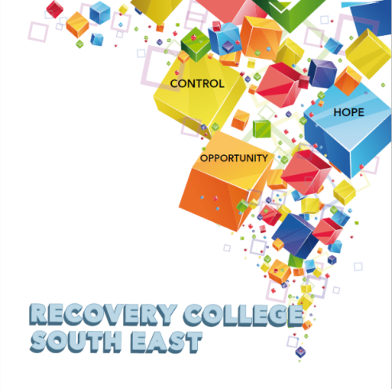

**Student Enrolment Form**

|  |  |  |
| --- | --- | --- |
| **PLEASE COMPLETE USING BLOCK CAPITAL LETTERS** | | |
| **Surname:** |  | |
| **First name(s)** |  | |
| **Address:** |  | |
| **Telephone:** | **Mobile** | **Home/Work** |
| **Email:** |  | |
| **All our workshops are based around discussion with some written exercises at your own discretion.** | | |

**I would like to register for the following course/s**

|  |  |
| --- | --- |
| **Course title** | **Commencement date** |
|  |  |
|  |  |
|  |  |

***All our Workshops are free however, there is an enrolment fee of €5 per semester, per student. Our workshops are also open to everyone.***

**Student Signature _________________________________ Date ______**

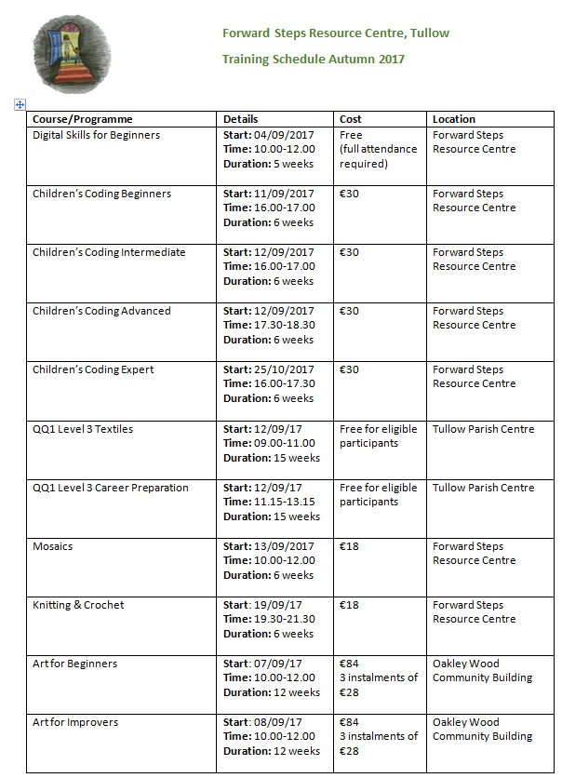

|  |  |  |  |
| --- | --- | --- | --- |
| Spanish for Beginners | **Start:** 03/10/2017  **Time:** 10.00-12.00  **Duration:** 6 weeks | €18 | Forward Steps Resource Centre |
| New Ideas for Family Cooking | **Start:** 02/11/2017  **Time:** 10.00-13.00  **Duration:** 4 weeks | €20 | Oakley Wood Community Building |
| Beginners Arts and Craft | **Start:** 11/09/2017  **Time:** 18.30-20.30  **Duration:** 6 weeks | €18  (for absolute beginners) | Forward Steps Resource Centre |
| Nails Decoration (Gel/Shellac) | **Start:** Sept 2017  **Time:** 18.00-20.00  **Duration:** 6 weeks | €35 | Forward Steps Resource Centre |
| Cooking on a Budget - Fakeaways & Healthy Eating | **Start:** Sept 2017  **Time:** 10.00-12.00  **Duration:** 6 weeks | €35 | TBC |

**\*All courses are offered subject to availability and may be changed. Waiting lists may be in operation.**

**Other activities:**

|  |  |  |  |
| --- | --- | --- | --- |
| Parent & Toddler Group  (for parents, guardians, grandparents of preschool children) | **Start:** 04/09/2017  **Time:** 11.00-12.30  **Duration:** ongoing | €2 per family per week | Forward Steps Resource Centre |
| Failte Isteach (English language programme) | **Start:** 07/09/2017  **Time:** 18.00-21.00  **Duration:** ongoing | Free | Forward Steps Resource Centre |

**For more information, or to register for any of the above contact:**

**Forward Steps Resource Centre 059 9152776**

**Sharon 086 1895684**

**Sandra 086 8555294**